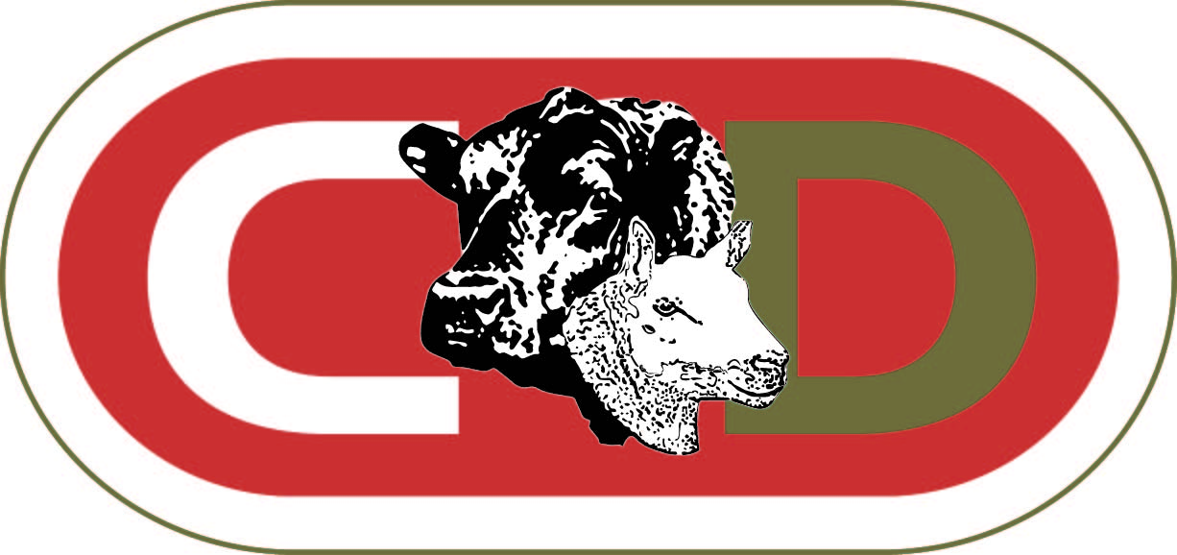
C & D AUCTION MARTS LIMITED
TOWNFOOT, LONGTOWN, CARLISLE CA6 5LY
Tel: 01228 791215
ENTRY FORM FOR SALE OF PLANT, EQUIPMENT, MACHINERY & TOOLS

SALE DATE………………………………………………………………

Lot Number | Full description of item | Reserve Price  (If applicable)

Full trading title …………………………………………………… VAT Registered : Yes / No

Address …………………………………………………... If Yes, VAT number…………………………………………….

…………………………………………………… Telephone number……………………………………………..

Postcode ……………………………………………………

